**CloudTables-Manager: a web interface for running on desktop or tablet computer for restaurant managers to manage their own restaurants.**

**Task 2: Analysis and Specify Software Quality Requirements**

The CloudTables-Manager subsystem is intended to offer restaurant managers a safe, efficient, and user-friendly interface for controlling restaurant operations from desktop or tablet devices.

The system will use strong measures to preserve security and privacy, such as role-based access control (RBAC) with multi-factor authentication (MFA) and secure password storage utilising algorithms like bcrypt or Argon2. Data will be encrypted both at rest (using AES-256) and in transit (using TLS 1.3 or above). The solution will verify compliance with data protection standards such as GDPR and CCPA, offer options for deleting customer data, and keep tamper-proof audit records for accountability.

In terms of performance, the application will ensure that pages and operations load in 2 seconds or less under normal conditions, and database queries execute in 200 milliseconds. Resource utilisation will be optimised to keep it below 75% under ordinary loads, and minimal offline functionality will be offered to minimise internet outages.

The subsystem's reliability will be maintained with a target uptime of 99.9%, limiting downtime to no more than 8.76 hours per year. Robust error handling will guarantee that unforeseen errors are logged and handled graciously, with user-friendly error messages to guide recovery. ACID compliance will ensure data integrity for transactional activities, while daily backups will be kept for at least 30 days and recoverable with a single click in 5 minutes.

To facilitate growth, the subsystem will prioritise scalability. It will provide horizontal scalability, allowing up to 500 concurrent users per manager without performance degradation, as well as efficiently managing data quantities of up to 1TB initially, with a scalable limit of 10TB. Under double the expected demand, the design will maintain at least 80% of peak performance while also providing scalable API endpoints for third-party integrations like payment gateways and analytics tools.

These quality requirements ensure that CloudTables-Manager is a safe, high-performing, dependable, and scalable solution that successfully satisfies restaurant managers' goals while providing an excellent user experience.

3a)

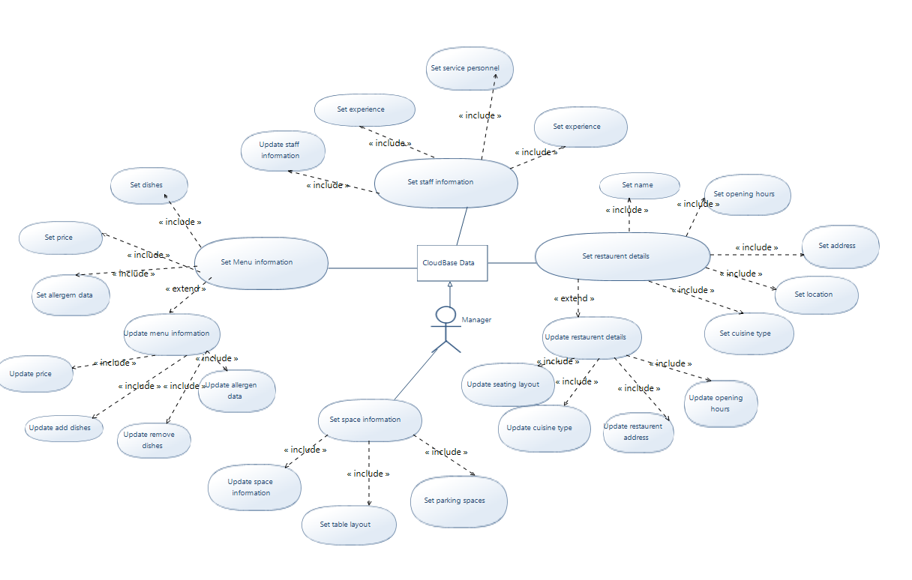

3b)